**\* MVC Architecture**

The MVC model defines web applications with 3 logic layer:

* The business logic (Model Logic).
* The display layer (View Logic).
* The input control (Controller Logic).

**MODEL**

* The Model is responsible for managing the data of application.
* It responds to the request from the view and it also responds to instructions from the controller update itself.
* It is the lowest level of the pattern which is responsible for maintaining data.
* The Model represents the application core (for instance of a list of database records).
* It is also called the domain layer

**VIEW**

* The View display the data (the database records).
* A view requests information from the model, that it needs to generate an output representation.
* It presents data in a particular format like JSP, ASP, PHP, CSHTML.
* MVC is often seen in web applications, where the view is the HTML page.

**CONTROLLER**

* The Controller is the part of application that handles user interaction.
* Typically controllers read data from a view, control user input and send input data to the model.
* It handle the input, typically user actions and may invoke changes on the model and view.

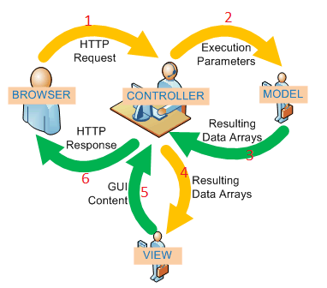

**MVC architecture diagram (references to slideshare.net)**

1. User interacts with the interface through browser, browser sends Http request to controller.
2. A controller handles the input event from the interface. The controller accesses the model, possibly updating it in a way appropriate to the user’s action (e.g., controller update user’s shopping cart).
3. The model returns resulting data to controller.
4. The Controller sends data to request view.
5. The view uses the data to generate an appropriate user interface and returns Html code to controller.
6. The controller returns appropriate interface and data to browser.